Assignment 1

# Aim:

Design a Company Registration Form with CSS styles that include all of the form tag's features. Show the relevant Form output in a compatible browser

# Code:

<html>

<head>

Company Registration Practical 2

</head>

<body style = "background-color: beige;">

<center>

<u><h1> Company Registration Form </h1></u>

<p> Enter the following necessary details </p>

<form action = "/action_page.php>

<label for = "n"> Name </label>

<input type = "text" id = "n" name = "n"> <br>

<br>

<label for="email"> Email ID </label>

<input type="email" id="email" name="email"> <br>

<p> Gender </p>

<input type="radio" id="Female" name="Gen" value="Female">

<label for="Female"> Female </label>

<input type="radio" id="Male" name="Gen" value="Male">

<label for="Male"> Male </label>

<input type="radio" id="Others" name="Gen" value="Others">

<label for="Others"> Others </label>

<br><br>

<label for="id"> Employee ID </label>

<input type="number" id="id" name="id" min = "00" Max ="100" <br>

<br>

<script>

function verifyPassword() {

var pw = document.getElementById("pswd").value;

//check empty password field

if(pw == "") {

document.getElementById("message").innerHTML = "**Fill the password please!";

return false;

}

//minimum password length validation

if(pw.length < 8) {

document.getElementById("message").innerHTML = "**Password length must be atleast 8 characters";

return false;

}

//maximum length of password validation

if(pw.length > 15) {

document.getElementById("message").innerHTML = "**Password length must not exceed 15 characters";

return false;

} else {

alert("Password is correct");

}

}

</script>

<br>

<td> Enter Password </td>

<input type = "password" id = "pswd" value = "">

<span id = "message" style="color:red"> </span> <br>

<br>

<td> Confirm Password </td>

<input type = "password" name = "pswd2"> <br><br>

<script>

function matchPassword() {

var pwd = document.getElementById("pswd1");

var pwd2 = document.getElementById("pswd2");

if(pw1 != pw2)

{

alert("Passwords did not match");

} else {

alert("Password created successfully");

}

}

</script>

<script>

function Submit(){

alert("Submitted Successfully");

</script>

<label for = "file"> Upload your CV </label>

<input type = "file" id="docpicker" accept = ".doc, .docx, application/.msword, application/vnd.openxmlformats-officedocument.wordprocessingml.document" />

<br><br>

<button type = "submit" onclick="matchPassword()">Check</button>

<button type = "submit" onclick="Submit()">Submit</button>

<button type = "reset" value = "Reset" >Reset</button>

</form>

</center>

</body>

</html>

# Output:

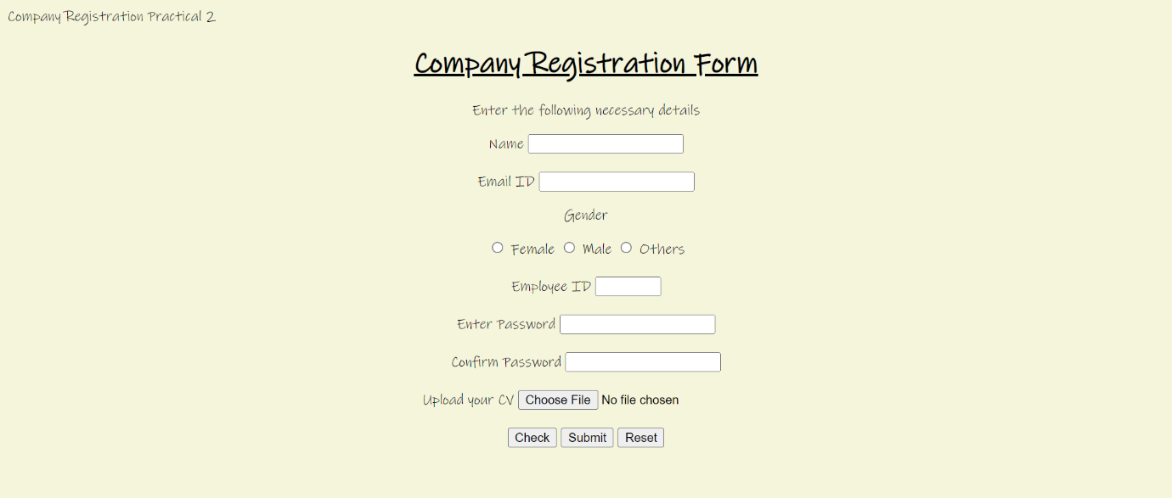

Assignment 2

# Aim:

Create an HTML script for Coffee: shop online web content utilizing HTML tags and CSS capabilities. Use a coffee cup and relevant images to enhance the presentation. Provide a coffee type selection option, as well as a rate for the coffee type pick. Tables should be used whenever possible.

# Code:

<!DOCTYPE html>

<html>

<head>

<meta name="viewport" content="width=device-width, initial-scale=1">

<style>

body{

font-family: 'Gill Sans', 'Trebuchet MS', 'Lucida Sans Unicode';

background-color: rgb(48, 26, 8);

}

.container {

padding: 50px;

background-color: rgb(108, 87, 59);

}

input[type=text], input[type=password], textarea {

width: 100%;

padding: 15px;

margin: 5px 0 22px 0;

display: inline-block;

border: none;

background: #f1f1f1;

}

input[type=text]:focus, input[type=password]:focus {

background-color: lightgoldenrodyellow;

outline: none;

}

div {

padding: 10px 0;

}

hr {

border: 1px solid #f1f1f1;

margin-bottom: 25px;

}

.center {

display: block;

margin-left: auto;

margin-right: auto;

width: 50%;

}

.registerbtn {

background-color: #4CAF50;

color: white;

padding: 16px 20px;

margin: 8px 0;

border: none;

cursor: pointer;

width: 100%;

opacity: 0.9;

}

.text {

background-color: rgb(79, 59, 14);

color: darkgoldenrod;

font-size: 10vw; /* Responsive font size */

font-weight: bold;

margin: 0 auto; /* Center the text container */

padding: 10px;

width: 50%;

text-align: center; /* Center text */

position: absolute; /* Position text */

top: 30%; /* Position text in the middle */

left: 50%; /* Position text in the middle */

transform: translate(-50%, -50%); /* Position text in the middle */

mix-blend-mode: screen; /* This makes the cutout text possible */

}

.registerbtn:hover {

opacity: 1;

}

</style>

</head>

<body>

<form>

<div class="container">

<div class="text">COFFEE SHOP</div>

<img src="images/coffee.jpg" width="400" height="200" class="center"> <br>

<label> Please Enter your Name </label>

<input type="text" name="name" placeholder= "name" size="15" required />

<label>

Phone :

</label>

<input type="text" name="country code" placeholder="Country Code" value="+91" size="2"/>

<input type="text" name="phone" placeholder="phone no." size="10"/ required>

<div>

<label>

Coffee Cup Size :

</label>

<select>

<option value="Cup Size">Cup Size</option>

<option value="Small">Small</option>

<option value="Medium">Medium</option>

<option value="Large">Large</option>

</select>

</div>

<div>

<label>

Milk Prefrences :

</label><br>

<input type="radio" value="Cow Milk" name="gender" checked > Cow Milk

<input type="radio" value="Oat Milk" name="gender"> Oat Milk

<input type="radio" value="Almond Milk" name="gender"> Almond Milk

</div>

Special Instructions to Barista :

<textarea cols="70" rows="3" placeholder="Enter Instructions" value="Instructions" required>

</textarea>

<button type="submit" class="Place my Ordertn">Place my Order</button>

</form>

</body>

</html>

# Output:

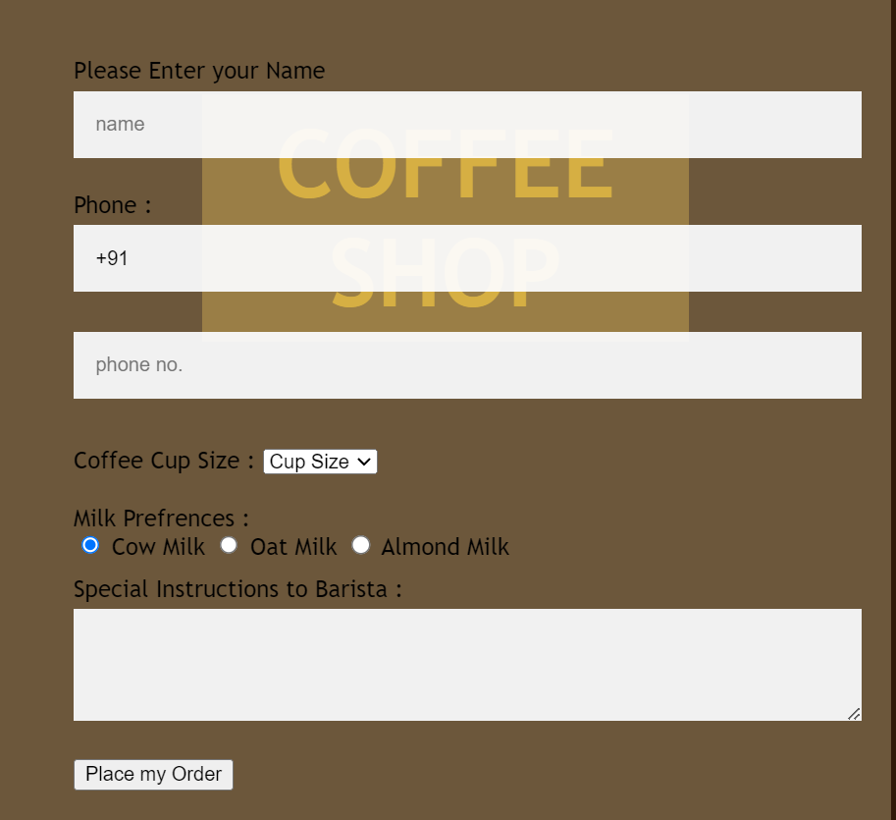

Assignment 3

# Aim:

Write a JavaScript code to perform arithmetic operation by taking values from users (Add,Sub, Mul,Div)(1. 4 Button, 2.Dropdown)

# Code:

<!DOCTYPE html>

<html>

<head> <h1> Assignment 3: To perform arithmetic operations </h1></head><br><br>

<body>

<label for = "n1"> Enter the first number </label>

<input type = "text" name = "n1" id = "n1"> <br> <br>

<label for = "n2"> Enter the second number </label>

<input type = "text" name = "n2" id = "n2"> <br> <br>

<select name="operation" id="operation">

<option> Choose option </option>

<option value ="add"> Addition </option>

<option value ="sub"> Subtraction </option>

<option value ="mul"> Multiplication </option>

<option value ="div"> Division </option>

</select>

<button onclick="action()"> Submit </button>

<p> Result: </p>

<p id="text"> </p>

<style>

body{

background-colour: beige;

font-color: green;

font-size: 12px;

text-align: center;

}

</style>

<script>

function action(){

var a = Number(document.getElementById("n1").value);

var b = Number(document.getElementById("n2").value);

var choice = document.getElementById("operation").value;

var h1 = document.getElementById("text");

if(choice == "add"){ h1.innerHTML = a+b;}

else if (choice == "sub") { h1.innerHTML = a-b;}

else if (choice == "mul") { h1.innerHTML = a*b;}

else if (choice == "div") { h1.innerHTML = a/b;}

else { alert("Invalid Choice");}

}

</script>

</body>

</html>

# Output:

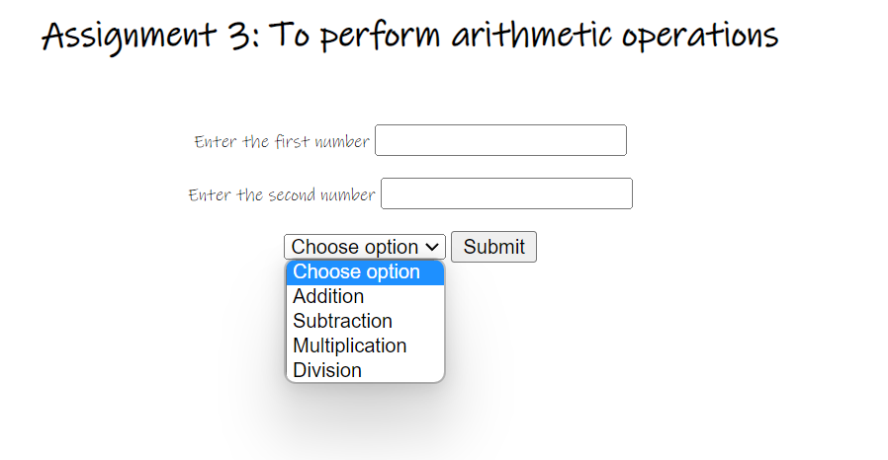

Assignment 4

# Aim:

Create one button on every click of button different colors should be applied to background.

# Code:

<!DOCTYPE html>

<html>

<head>

<title> Background colour changer at random

</title>

</head>

<body>

<p> Assignment 4: Change the colour of a background with the help of a click </p> <br>

<input type ="button" id = "btn" value ="change colour">

<script>

let color= ['pink', 'blue', 'green', 'orange', 'purple', 'red'];

let btn= document.getElementById('btn');

btn.addEventListener('click',function(){

let randomColor = color[Math.floor(Math.random()* color.length)];

document.body.style.background=randomColor;

});

</script>

<style>

body{

background: beige;

font-size: 20px;

font-color: black;

}

#btn{

background: pink;

border-colour: orange;

position: absolute;

top: 45%;

left: 145%

padding: 20px;

border-radius: 10px;

border-style: inset;

font-size: 20px;

color: green;

}

</style>

</body>

</html>

# Output:

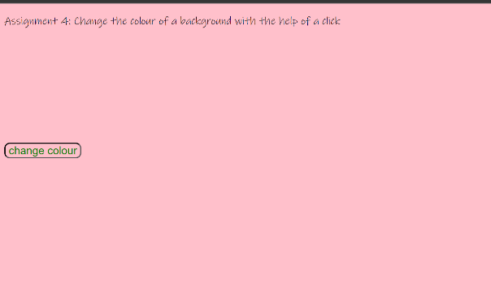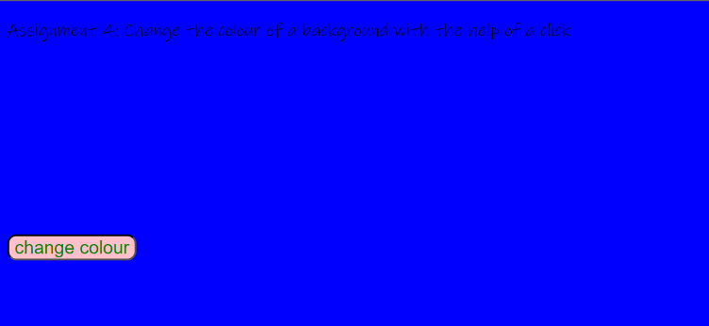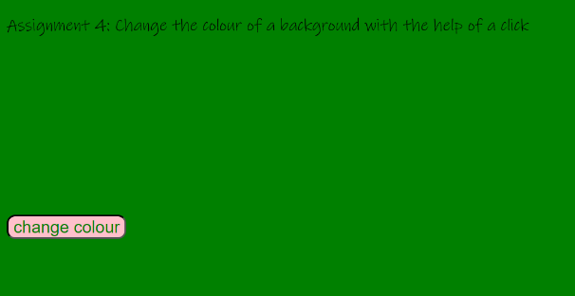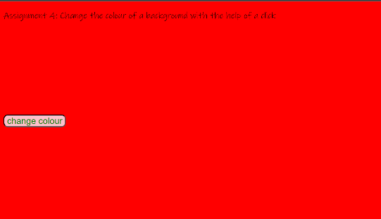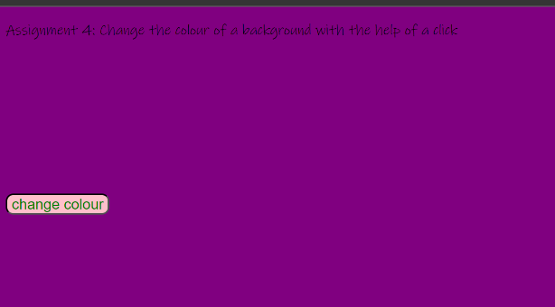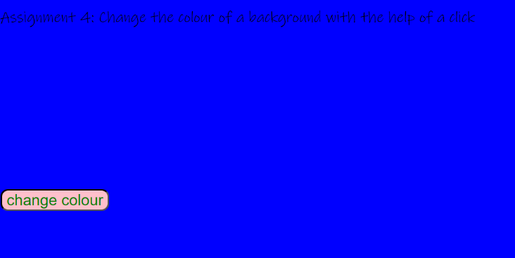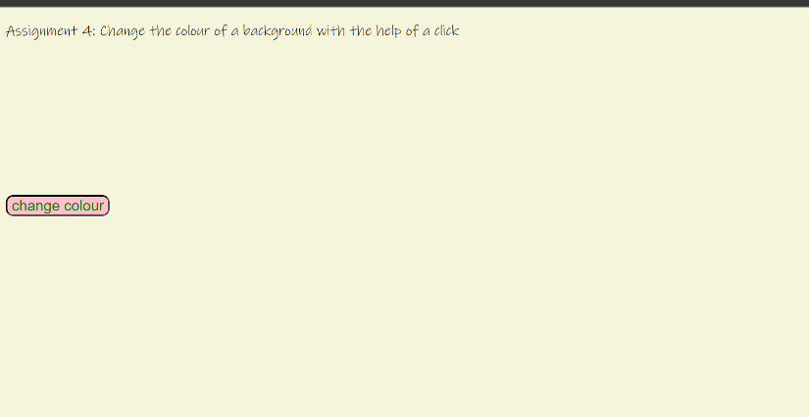

Assignment 5

# Aim:

Write a Javascript code to append static row to the table on click of button

# Code:

<html>

<head>

Insert a row into a table

</head>

<body>

<h1>

Assignment 5: Write a Javascript code to append static row to the table on a click.

</h1>

<br><br>

<p> Things to buy </p>

<br>

<table id= "myTable">

<tr> <th> Item </th> <th> Amount </th> </tr>

<tr> <td> Grey Wool </td> <td> 4 </td> <tr>

<tr> <td> Purple mixed Wool </td> <td> 2 </td> </tr

<tr> <td> Dark Green Wool </td> <td> 2 </td> </tr>

<tr> <td> Blue mixed Wool </td> <td> 3 </td> </tr>

</table>

<br>

<button type="button" onclick="myFunction()">

Click This To add a Row Below

</button>

<button type="button" onclick="myFunction2()">

Click This To add a Row Above the Heading

</button>

<script>

function myFunction() {

var table = document.getElementById("myTable");

var row = table.insertRow(-1);

var cell1 = row.insertCell(0);

var cell2 = row.insertCell(1);

cell1.innerHTML = "New Item";

cell2.innerHTML = "New Amount";

}

function myFunction2() {

var table = document.getElementById("myTable");

var row = table.insertRow(0);

var cell1 = row.insertCell(0);

var cell2 = row.insertCell(1);

cell1.innerHTML = "New Item";

cell2.innerHTML = "New Amount";

}

</script>

<style>

table,th,td{

border: 1px solid purple;

border-style: inset;

border-radius: 10px;

}

</style>

</body>

</html>

# Output:

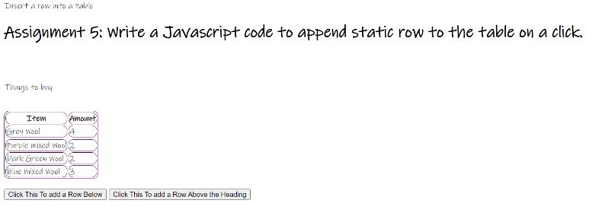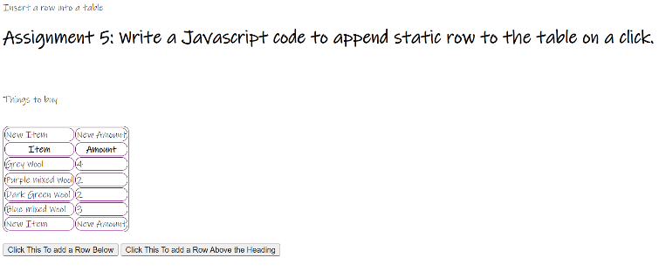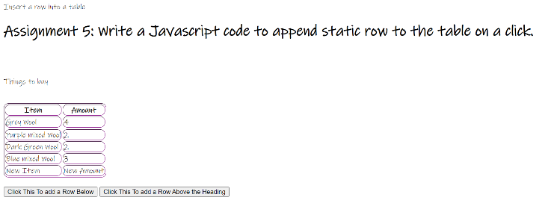

Assignment 6

# Aim:

Write a Javascript to create shopping applications which adds the books in cart, updates the existing books, delete the book and display the same. Create proper UI for the same.

# Code:

## Application:

<!DOCTYPE html>

<html>

<head>

<link rel="stylesheet" href="style.css" />

</head>

<body>

<h2> Assignment 6 </h2>

<div class="container">

<h1>Shopping Cart</h1>

<table id="cart">

<tr>

<th>Title</th>

<th>Author</th>

<th>Price</th>

<th>Action</th>

</tr>

</table>

<input

class="input-field"

id="title"

type="text"

placeholder="Title"

/>

<input

class="input-field"

id="author"

type="text"

placeholder="Author"

/>

<input

class="input-field"

id="price"

type="text"

placeholder="Price"

/>

<button class="btn" id="addBtn">Add to Cart</button>

</div>

<script src="script.js"></script>

</body>

</html>

## Style:

body{

background-color: pink;

}

h1{

font-size: 20px;

color: green;

text-align: center;

margin-top: 50px;

}

table{

width:100%;

border-style: dotted;

border-radius:20px;

border: 1px solid purple;

}

th, td{

border: 1px solid pink;

padding: 8px;

text-align: left;

border-radius: 20px;

}

th{

color: blue;

}

input[type="text"]

input[type ="number"]{

width:100%;

padding: 12px 20px;

margin: 8px 0;

box-sizing: border-box;

border:2px solid pink;

border-radius: 10px;

}

input{

padding:10px;

border-radius: 5px;

border: 1px solid pink;

margin-top: 10px;

width: 200px;

}

input[type="text"]:focus, input[type="number"]:focus{border: 2px solid #555}

.form-container{

width:50px;

margin:0 auto;

text-align: center;

}

.form-container h3{

margin-top:0;

font-size:36px;

}

.form-container label{

display: block;

margin-bottom: 8px;

font-size:18px;

}

.form-container input[type="submit"]{

width: 50%;

padding: 14px 20px;

margin:20px 0;

border-radius: 10px;

backgound-color: #228b22 /*forest green*/

color: white;

cursor: pointer;

}

.delete-button{

background-color: #ff0000 /*red*/

color: white;

padding: 5px 10px;

border-radius: 10px;

cursor: pointer;

font-size: 18px;

}

.update-button{

background-color: dark orange;

color: white;

padding: 5px 10px;

border-radius: 10px;

cursor: pointer;

font-size: 18px;

}

## Script:

const addButton = document.getElementById("addBtn");

const cartTable = document.getElementById("cart");

let cartItems = [];

addButton.addEventListener("click", function () {

const title = document.getElementById("title").value;

const author = document.getElementById("author").value;

const price = document.getElementById("price").value;

if (title && author && price) {

const book = { title, author, price };

const existingBook = cartItems.find((b) => b.title === title);

if (existingBook) {

existingBook.author = author;

existingBook.price = price;

} else {

cartItems.push(book);

}

renderCart();

}

});

function renderCart() {

cartTable.innerHTML = `

<tr>

<th>Title</th>

<th>Author</th>

<th>Price</th>

<th>Action</th>

</tr>

`;

for (let i = 0; i < cartItems.length; i++) {

const book = cartItems[i];

const tr = document.createElement("tr");

tr.innerHTML = `

<td>${book.title}</td>

<td>${book.author}</td>

<td>${book.price}</td>

<td>

<button class="delete-button" data-index="${i}">Delete</button>

</td>

`;

cartTable.appendChild(tr);

}

const deleteButtons = document.querySelectorAll(".delete-button");

for (const deleteButton of deleteButtons) {

deleteButton.addEventListener("click", function () {

const index = this.getAttribute("data-index");

cartItems.splice(index, 1);

renderCart();

});

}

}

renderCart();

# Output:

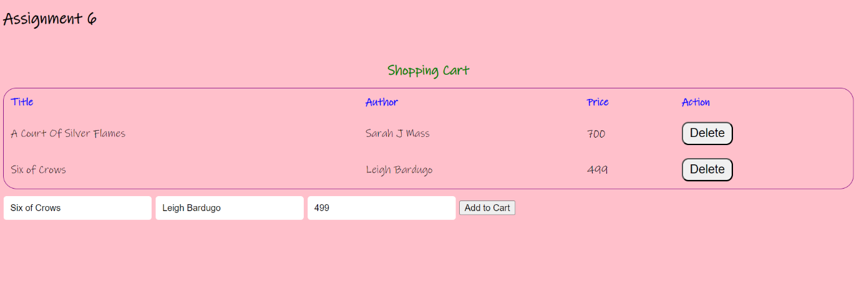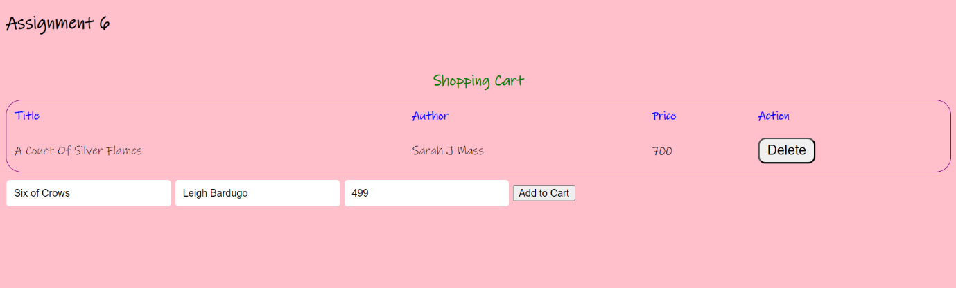

Assignment 7

# Aim:

Write a PHP script to take number from user and print the table of that number.

# Code:

<!DOCTYPE html>

<html>

<head>

    <title>Arrays in PHP</title>

    <style>

        body {

            font-family: Arial, sans-serif;

            background-color: #f2f2f2;

        }

        h2 {

            text-align: center;

            margin-top: 30px;

            color: #1e90ff;

        }

        table {

            margin: 0 auto;

            border-collapse: collapse;

            background-color: #fff;

            box-shadow: 0 0 10px rgba(0, 0, 0, 0.1);

            margin-top: 50px;

            border-radius: 10px;

        }

        th,

        td {

            padding: 10px;

            border: 1px solid #ddd;

            text-align: center;

        }

        th {

            background-color: #1e90ff;

            color: #fff;

            font-weight: bold;

            text-transform: uppercase;

            letter-spacing: 1px;

            font-size: 14px;

        }

        td {

            color: #333;

            font-size: 14px; }

        .numeric {

            background-color: #ffd54f; }

        .assoc {

            background-color: #f44336; }

        .multi {

            background-color: #4caf50; }

    </style></head>

<body>

    <h2>Numeric Array</h2>

    <table class="numeric">

        <tr>

            <th>Index</th>

            <th>Value</th>

        </tr>

        <?php

        $numeric_array = array(10, 20, 30, 40, 50);

        foreach ($numeric_array as $index => $value) {

            echo "<tr><td>$index</td><td>$value</td></tr>";

        }

        ?>

    </table>

    <h2>Associative Array</h2>

    <table class="assoc">

        <tr>

            <th>Key</th>

            <th>Value</th>

        </tr>

        <?php

        $assoc_array = array("name" => "John", "age" => 30, "city" => "New York");

        foreach ($assoc_array as $key => $value) {

            echo "<tr><td>$key</td><td>$value</td></tr>";

        } ?>

    </table>

    <h2>Multidimensional Array</h2>

    <table class="multi">

        <tr>

            <th>Name</th>

            <th>Age</th>

            <th>City</th>

        </tr>

        <?php

        $multi_array = array(

            array("name" => "John", "age" => 30, "city" => "New York"),

            array("name" => "Mary", "age" => 25, "city" => "Los Angeles"),

            array("name" => "Tom", "age" => 35, "city" => "Chicago")

        );

        foreach ($multi_array as $item) {

            echo "<tr><td>{$item['name']}</td><td>{$item['age']}</td><td>{$item['city']}</td></tr>";

        } ?>

    </table> </body> </html>

# Output:

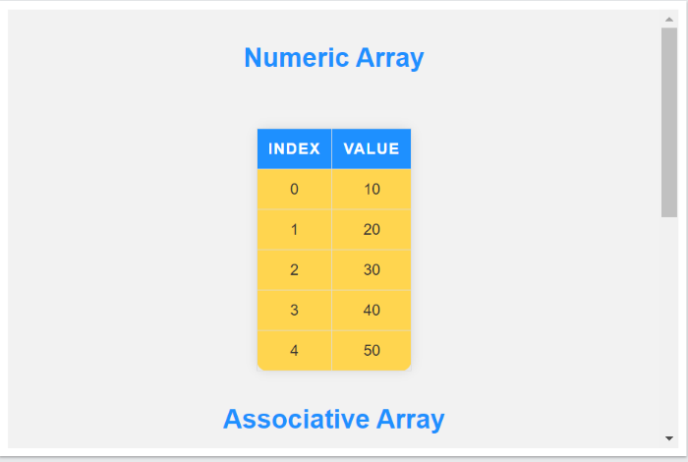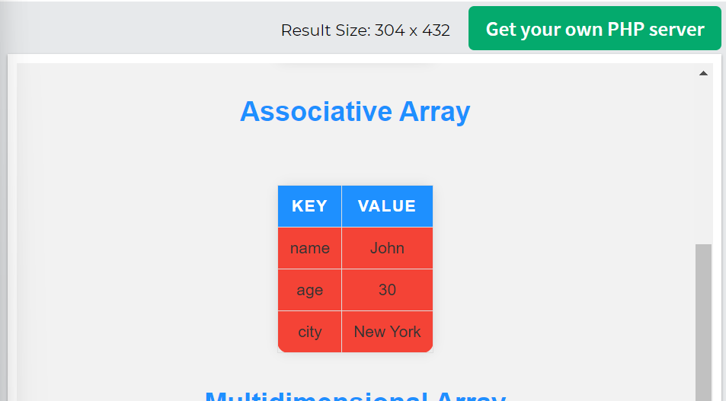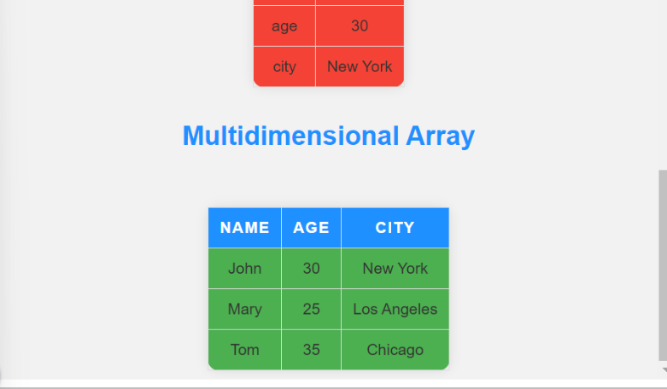

Assignment 8

# Aim:

Design a shopping application form with following fields[itemID, itemName, itemQuantity] Write a PHP script to add and display the items.

# Code:

<DOCTYLE! html>

<html>

<head> <h1> Assignment 8 </h1> </head>

<body>

 <div class="container mt-5">

        <h1>Add Grocery List</h1>

        <form action="add.php" method="POST">

            <div class="form-group">

                <label>Item name</label>

                <input type="text"

                    class="form-control"

                    placeholder="Item name"

                    name="iname" /> </div>

            <div class="form-group">

                <label>Item quantity</label>

                <input type="text"

                    class="form-control"

                    placeholder="Item quantity"

                    name="iqty" /> </div>

            <div class="form-group">

                <label>Item status</label>

                <select class="form-control"

                    name="istatus">

                    <option value="0">PENDING</option>

                    <option value="1"> BOUGHT</option>

                    <option value="2">NOT AVAILABLE</option>

                </select></div>

            <div class="form-group">

                <label>Date</label>

                <input type="date"

                    class="form-control"

                    placeholder="Date"

                    name="idate"></div>

            <div class="form-group">

                <input type="submit"

                    value="Add"

                    class="btn btn-danger"

                    name="btn"> </div> </form> </div>

    <?php

        if(isset($_POST["btn"])) {

            include("connect.php");

            $item_name=$_POST['iname'];

            $item_qty=$_POST['iqty'];

            $item_status=$_POST['istatus'];

            $date=$_POST['idate'];

            $q="insert into grocerytb(Item_name,

            Item_Quantity,Item_status,Date)

            values('$item_name',$item_qty,

            '$item_status','$date')";

            mysqli_query($con,$q);

            header("location:index.php");

        } ?>

</body> </html>

# Output

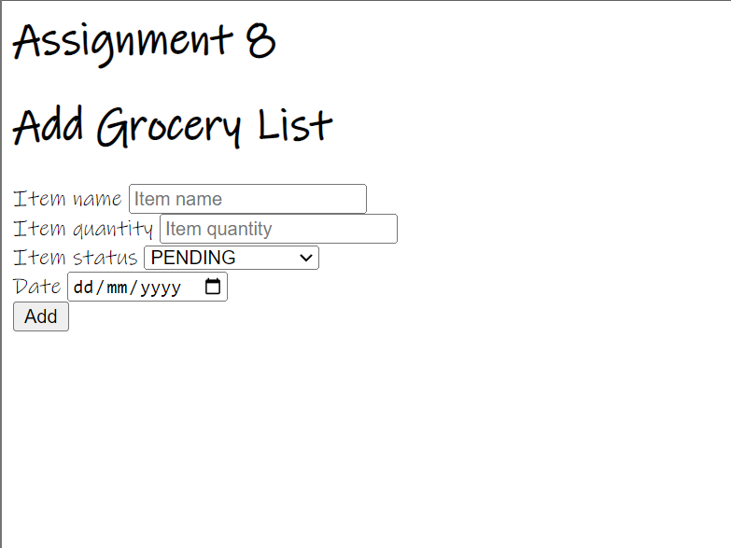

Assignment 10

# Aim:

Write a JQuery code to give animation to div on click of a button.

# Code:

<!DOCTYPE html>

<html>

<head>

<script src="https://ajax.googleapis.com/ajax/libs/jquery/3.6.3/jquery.min.js"></script>

<script>

$(document).ready(function(){

  $("button").click(function(){

    $("div").animate({left: '250px'});

  });

});

</script>

</head>

<body>

<button>Start Animation</button>

<div style="background:#98bf21;height:100px;width:100px;position:absolute;"></div>

</body>

</html>

# Output:

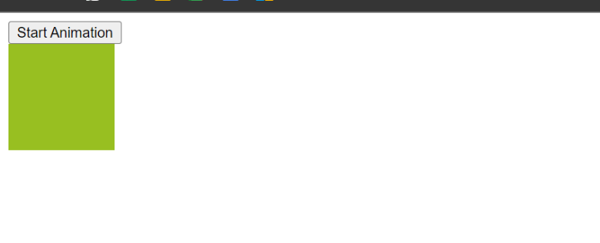

After pressing the button

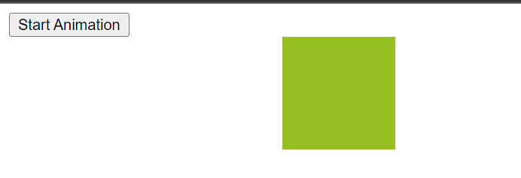

Assignment 11

# Aim:

Write a JQuery code to add dynamic element on page on click of button

# Code:

## Core code:

<!DOCTYPE html>

<html lang="en">

    <head>

        <meta charset="UTF-8" />

        <meta http-equiv="X-UA-Compatible" content="IE=edge" />

        <meta name="viewport" content="width=device-width, initial-scale=1.0" />

        <title>Document</title>

        <link rel="stylesheet" href="style.css" />

    </head>

    <body>

        <div>

            <button id="add-element-button">Add Element</button>

            <div id="elements-container"></div>

        </div>

        <script src="https://code.jquery.com/jquery-3.6.0.min.js"></script>

        <script src="script.js"></script>

    </body>

</html>

## Css:

.new-element {

    padding: 10px;

    margin: 10px;

    background-color: #f2f2f2;

    border: 1px solid #ddd;

    border-radius: 5px;

    box-sizing: border-box;

    width: 100%;

    max-width: 600px;

}

@media only screen and (min-width: 768px) {

    .new-element {

        width: calc(50% - 20px);

    }

}

@media only screen and (min-width: 992px) {

    .new-element {

        width: calc(33.33% - 20px);

    }

}

## JQuery:

(function ($) {

    var counter = 1;

    function createElement() {

        var newElement = $("<div>", {

            id: "element-" + counter,

            class: "new-element",

            text: "This is element " + counter,

        });

        $("#elements-container").append(newElement);

        counter++;

    }

    $(document).ready(function () {

        $("#add-element-button").click(createElement);

    });

})(jQuery);

# Output:

